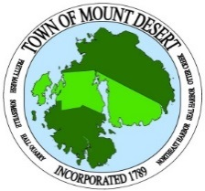
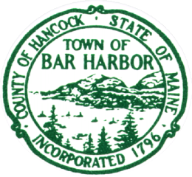
MOUNT DESERT POLICE DEPARTMENT
BAR HARBOR POLICE DEPARTMENT

Email completed forms to:
krichter@mdpolice.org

BHPD MDPD
37 Firefly Lane 21 Sea Street, PO Box 248
Bar Harbor, Maine 04609 NE Harbor, ME 04662
Tel: 207-288-3391 Tel: 207-276-5111

OUTSIDE DETAIL REQUEST FORM
Outside details involving traffic control, parking and maintaining order
are charged at $100.00 per hour with a 3 hour minimum.
Date of Event |  | _____________________
Time of Event |  | start | ______________ |  | end | ___________
PERSON REQUESTING _______________________________________________
PHONE NUMBER FOR ABOVE _________________________________________
ALTERNATE CONTACT AND PHONE # __________________________________
___________________________________________________________________
LOCATION AND TYPE OF EVENT ______________________________________
___________________________________________________________________
DOES THIS EVENT INVOLVE THE USE OF PUBLIC SPACE? YES____ NO____
If YES, there may be a permit required. Have you applied for or obtained a permit from the town? YES____ NO____
Approximate # of people attending the event ____________________________
# OF OFFICERS REQUESTED |  |  |  | _____________________
SPECIAL CONSIDERATIONS OR INSTRUCTIONS FOR THE OFFICERS
___________________________________________________________________
___________________________________________________________________
___________________________________________________________________
___________________________________________________________________
 |  |  | BILLING INFORMATION
 |  |  | ______________________________________
 | NAME & |  | ______________________________________
MAILING ADDRESS |  |  | ______________________________________
 |  |  | ______________________________________
EMAIL ADDRESS FOR BILLING (optional)- _______________________________
OFFICE USE ONLY – Amount Due _______________________________

